**Chapter 9 – OUR DAUGHTER, SANDRA LEE BROWNING “SANDY”**

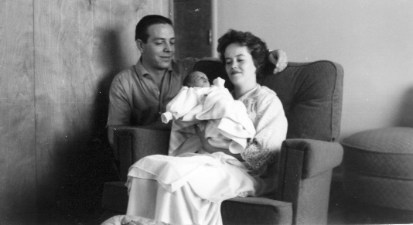The Lord did bless us with a child - a beautiful baby girl. Our little Sandra Lee was born on November 21, 1961. When I say “little”, I mean little. She weighed only 5 lbs 13 oz. She had strawberry red hair - so we named her Sandra Lee, calling her Sandi. Ken said we already had that name picked out, but I don’t remember it that way. I remember seeing her hair and thinking she should be called “Sandy.”

She was born on a cold snowy night. I had been in labor for 23 hours. The funny thing about that was Ken was working two jobs (so we could get our home) and he would call me every hour to see how I was doing. My mom also called me every hour. The only problem was – one of them was calling me every half hour and so I would just get sat down or lay down and I would have to get up to answer the phone. (We didn’t have cordless phones in those days.) I finally told them that I would be better if they would quit calling me so often as it was wearing me out to keep getting up to answer the phone.

The roads were really bad when Ken drove me to the old “Dee Hospital” in Ogden. When they put me in the “prep” room, I heard someone screaming in the next room and it scared me. I thought “Oh, is sit going to be that bad?” I guess I was scared so bad that my labor stopped. The doctor, on call, gave me some sleeping pills and told Ken to take me home and that if it was false labor, I could get a good night’s rest and if it wasn’t, he would see me back in a few hours. Well, soon after we went to bed, the labor started again. Ken was asleep and I didn’t want to wake him and I didn’t want to go to the hospital and have them send me back home again – so I just waited it out until finally I had a showing and decided I’d better wake him as it scared me. He quickly got dressed and got me back to the hospital, and the doctor had to act quick for the baby was about here.

Later I found out that the mother who was screaming in the prep room next to mine was Launa Barrows, a friend in the ward who was having a miscarriage. This was her first child also. It was hard for Launa and Blaine to see Ken and I with Sandi, especially since Sandi had red hair and Blain’s hair was red and they had lost their little girl. We have seen Blaine and Launa a few times since we moved and Launa always asks about Sandi. They did have other children though.

I was in the hospital for 4 days. We didn't have private rooms like we do today, we had wards which had four beds (2 on the east side of the room and 2 on the west.) I enjoyed this as the four of us would become friends and had a good time visiting, seeing each other's babies, husbands, etc. It was a fun time. I think it was when Mike was born that I had the experience with the one nurse which I shall always remember. The four of us ladies were having a good time visiting and laughing when all of a sudden, a booming voice yelled at us from the doorway to "shut the windows, turn off the light and get to sleep". We looked at her and she practically filled the doorway. She was the biggest nurse I had ever seen, in fact I think she was the biggest woman I had ever seen. She looked like a woman wrestler. Boy, we scurried to close the windows, turn out the light and try to go to sleep. In the middle of the night my milk came in. I became more and more uncomfortable. I'm not like most women - when my milk comes in, I become engorged. I swell up so bad and am in a lot of pain. I didn't want to get up because I would have to go to this nurse and I was afraid of her, but I finally couldn't stand the pain any longer and got out of bed and went to find her. I explained what my problem was and she got me some hot towels to put on my breasts and got me a breast pump. While she was getting this for me, she apologized for being so upset with us, but told me how she had been on vacation and this was her first shift back. The other nurses had left everything in a mess and she was very frustrated and upset with them. I guess she had taken it out on us.

Anyway, back to when Sandi was born. I had Thanksgiving dinner in the hospital on the day Ken took us home. I later found out that Ken didn't get to eat a Thanksgiving dinner that year. I wish I had shared mine with him, but I thought his family would invite him or bring him over a plate - guess I didn't think much about it. We had lots of company that day, and for several days. I can remember Hal & Jean & Joan & Ralph among others. I also remember wishing they would leave because I was weak and needed to lie down, but mainly my milk was coming in and I was getting engorged, and felt I was going to pass out. I remember when they left, I went into the bath room and stripped down to my waist and looked in the mirror. I was "huge" and I hurt so bad. I didn't know what to do. Ken didn't know what to do for me. I started to cry, and about that time my wonderful Mom came. Ken let her in and told her I was in the bathroom crying. She came in, got me into bed, put towels in hot water and draped over me, got me some aspirin, etc. I was so thankful she came at that time. She said I looked like "death warmed over". I felt that way too. She told me that my grandmother Bushnell always became engorged also, but she (Mom) never did. I wasn't happy to take after Grandma in that. Anyway, after a couple of days I was doing much better - at least in that respect, but Sandi had the colic and would scream night and day. The most she would sleep was 20 minutes at a time (and I'm not exaggerating). I felt really bad for her because I knew she was in terrible pain by the way she would scream and pull her little legs in. The doctor explained to us that some children have colic, but it only lasts three months - that their intestines are not fully developed and so it causes them pain. Sandi had an extreme case of it. Mike and Jeff also had colic, but nothing like Sandi. The only time she wasn't screaming was the 20 minutes or less she was sleeping and when she was nursing. My mom finally told me she wondered if it was my milk - that maybe Sandi wasn't getting what she needed. I asked the doctor and he said it might be - so I quit nursing her. I regretted that because at least when I nursed her, she would keep it down, when I quit she threw up all the time, and she still screamed with the colic. We tried all the formulas, but nothing worked until we finally tried "Morning evaporated milk". She was able to keep it down better than any of the other higher priced formulas. It was hard to take her to church because Ken & I would take turns being out in the hall with her, and even then, it was hard for people to concentrate as they could still hear her screaming. Ken's sister, Margaret, had a baby daughter, Terry who was born about 3 months before Sandi. We would get together for family gatherings and we would lay the two babies down on a blanket on the bed or floor. Terry was a lot bigger and a happy baby. She would look over at Sandi who was always screaming.

With moving to a new area, and not knowing our neighbors very well at first and with Ken working a full-time job and also a part-time job, I had the major care of Sandi without much relief. Ken would come home at night after working at "Stop & Shop" and find me walking the floor with tears rolling down my cheeks and Sandi screaming. We tried everything anyone told us to do that might help - from holding her on our lab in front of the warm oven, to giving her paregoric, baby sleeping pills & colic medicine (doctor prescribed), Catnip & Fennel, rubbing her stomach, even a drop or two of Brandi etc., etc. Nothing worked.

One time the doctor had prescribed something and we gave it to her and she slept more than 20 minutes - in fact, after an hour and a half we were worried that maybe something was wrong. We called our neighbor, Pat Wiggins whose father was a pharmacist. She came over and looked at the prescription and said "it has sleeping medication in it, go to bed and get some sleep yourselves". We did, but she woke up soon after we got in bed. The medicine never worked after that.

Ken and I would take turns sleeping by Sandi's bassinet and we would pat her back throughout the night. Sometimes when I would be by the bassinet and patting her, Ken would be patting me in his sleep. (That's how bad it was) Although, one or the other of us would mainly be up walking the floor with her or feeding her. We didn't blame her as it wasn't her fault, she was hurting so bad and we felt sorry for her - but it was really hard. I remember telling my Grandmother Bushnell that Sandi would soon be three months old and over the colic. She said "Well, Mae, I have heard of some babies who have it for six months". I said "If Sandi has it for six months, I will be in the mental hospital in Provo". Thank goodness, she didn't. When three months was up, she was a completely different baby. She was finally a happy baby and we enjoyed her.

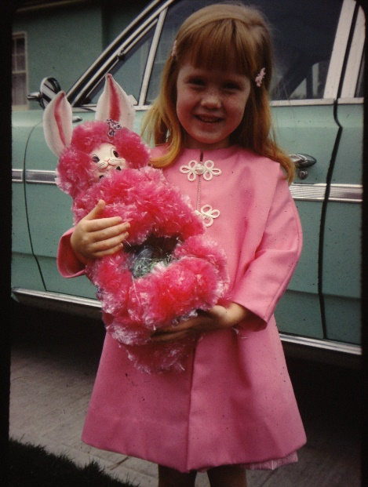 I had fun dressing my little girl in cute frilly clothes and doing her hair. I made the outfit she is wearing in this picture and also her bunny Easter basket. I made a lot of her clothes. I loved being a mother, and Ken and I loved our beautiful little daughter. She was a sweet and obedient little girl. We would take her to friend’s homes where we would put her in her pajamas and lay her down to sleep on their bed at bedtime while we played games or visited. When we left to go home, we would just pick her up and put her in her crib or bed at home and she would seldom ever wake up. If she did, we just gave her "her" blanket and she would go right back to sleep. She got attached to a yellow blanket, and she always wanted to go to sleep with it. I had a hard time getting it away from her long enough to get it washed and dried. We tried to give her other blankets, but she didn't want them, even if they were the same material or color. I remember one time we went to some friends and left her blanket there. She woke up as we were putting her in her crib. We reached for her blanket and couldn't find it. We ended up calling these friends and going over to get it as she just cried and wouldn't go to sleep without it. I finally had to cut it in half, so I could wash the one half while she had the other and that way, we had a "spare" at home if we happened to leave it again

I read different parenting books and articles as I wanted to be as good a mother as I could. One article I read said to get a large bowl or pan and put flour in it and then get cups, measuring spoons, etc., and let your chair have fun with it. I put some plastic under a chair, put the pan with flour and utensils, etc., and let Sandy go at it. She had lots of fun, but I think that was the last time I let her do that, as flour was all over her and all over the kitchen. It was a real mess. I was glad I didn’t give her any water to use with the flour.

Another incident that occurred, when Sandy was little, was one morning after a sleepless night, I got Sandy up, dressed, fed, and then got out her toys for her. I watched her starting to play and then I went back to bed for a much-needed nap. When I awoke, I realized I shouldn’t have done that as Sandy had found my red lipstick and had such fun with it. She had it all over her lips and face, all over our little chiwawa dog, on the walls, toys, etc. I had quite the mess to clean up.

I loved taking this sweet little daughter to the park, watching her ride her tricycle, watching Ken put her in the basket on his bike and taking her bike riding, Ken and I taking her to the zoo and watching her excitement as seeing the different animals, taking her out with us to visit her grandparents. She was my parent’s first grandchild and they loved her. My mom was such a cute grandmother to Sandy. My grandparents loved her too and I was glad they lived close so we could see them often too. My grandfather Porter had passed away and at this time she was living in the cute apartment that my dad built, and that Ken and I lived in for two years after we got married. My grandparents Bushnell lived next door to mom and dad. Grandma Porter always wanted to give Sandy a piece of candy when we visited her, and grandma wanted to show us her scrapbooks. Grandpa and Grandma Bushnell were so special too and I am thankful I have such wonderful parents and grandparents, and now Ken and I were married and we had a beautiful little daughter. Life was great!

Some memories of Sandi, include the one where she looked at our little chawawa dog and started counting to five and holding out her fingers as she counted, when the dog didn’t do what she wanted it to. She was mimicking me, when I would count to 5 when I asked her to pick up her toys (or something else) and she didn’t do it right away.

Another memory was when she was in Kindergarden. We were able to play with toys a part of the day back then. One of the dolls got broke (Can’t remember what on the doll). The teacher was going to throw it away, but Sandi said “No”, I can take it home and my dad can fix it, he can fix anything.” That was so cute and Ken did fix the doll. Sandi was right, her dad can fix anything. He has that logical mind and he can figure out how to do things and do them easy and do them “right”. Ken is a perfectionist also, so they do get fixed right.